Statistics Lecture 6.5: The Central Limit Theorem for Statistics. Using z-score, Standard Score

Requirements:
From a population with a mean of, μ, and a standard deviation, σ.

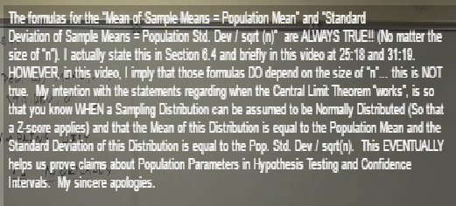

- 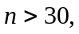 The sampling distribution of sample means is normally distributed.
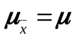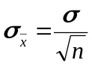
- 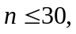 and the population is normally distributed, Then the sampling distribution of the sample means will be normally distributed.
- and you know nothing about the distribution of the population.
Cannot do this yet..

* Average of sample means 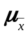
* Standard Deviation of sample means is also called the standard error.

Before
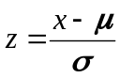 for an individual data value.

Now
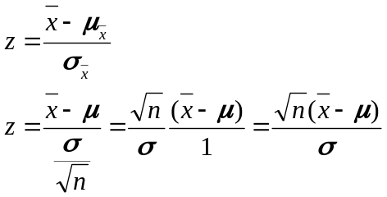 for an average for a group of values (sample)

Example
A population of men have a mean of 172 lbs and a standard deviation of 10 lbs.
Find the probability a randomly selected man will weight more than 175 lbs
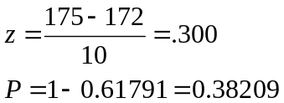

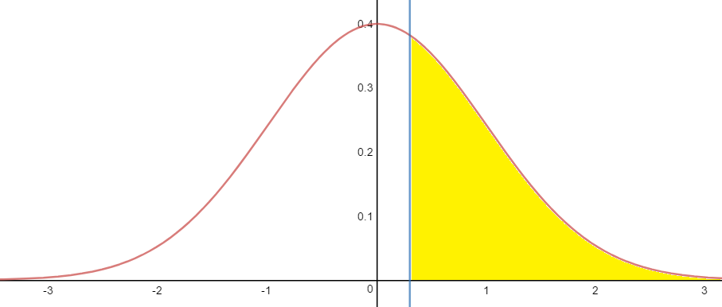
The probability a randomly selected man will weight more than 175 lbs is 38.21 %

Example
A population of men have a mean of 172 lbs and a standard deviation of 10 lbs.
Find the probability that a group of 20 men will have an average weight of more than 175 lbs.
Assume weight is normally distributed.
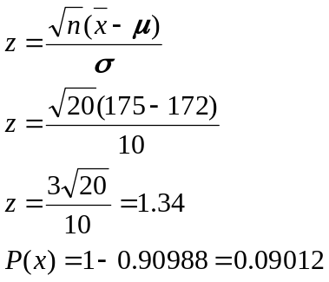
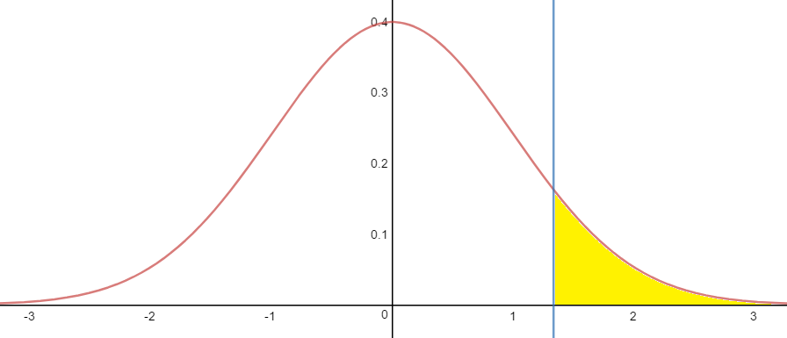
The probability that a group of 20 men will have an average weight of more than 175 lbs. is 9.01 %

Rare event rule.
If, under a given assumption, the probability of an event is “really small”, then that assumption is probably
wrong.

Example
Average body temperature 98.6 degrees with a standard deviation of 0.62 degrees.
A sample of 106 people were selected. What is the probability that the sample will be 98.2 or lower.
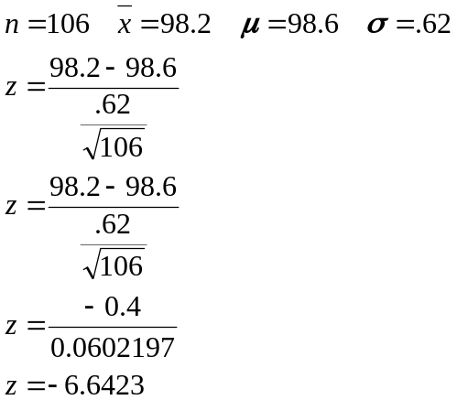

The probability of 106 people selected with a temperature of 98.2 or lower is 0.000000000015%
So small it is almost zeros.

